
Shahad Abdulla Alshehhi H00534149
Hessa Walid Ali H00534104
Shaikha Ebrahim Al Ali H00534278

CDS2413 – Programming of data science project Report
Global Health Coffee dataset

CRN: 15092
Instructor: Shawulu Nggada
Programming for Data Science
Global Health Coffee dataset

CLO1 [10 marks]

- Define the purpose of data analysis for the chosen dataset

The purpose of analyzing the Global Health Coffee dataset is to understand how coffee consumption and caffeine intake relate to global health and lifestyle factors such as life expectancy, BMI, physical activity, and sleep hours.
The analysis aims to identify patterns and relationships between caffeine use and various health outcomes across different populations.
The results can also help in making predictions and supporting public health or lifestyle recommendations related to coffee consumption.

- Identify and justify the type of programming used for data analysis

The programming language used for this analysis is Python. It was chosen because it is easy to use and has many helpful libraries like Pandas, NumPy, Matplotlib, and Scikit-learn that make data analysis, visualization, and machine learning simple and effective. We also have some background in Python from ICT 2013, which makes it easier to use for this project.

- Identify the type and purpose of the machine learning algorithm to be implemented for the chosen dataset

The machine learning algorithm used in this project is Linear Regression. It is a type of supervised learning used to predict continuous value. it is used to predict life expectancy based on different factors. We chose Linear Regression because the dataset already includes real values for life expectancy, and we want to find relationships between it and factors like coffee consumption, BMI, sleep hours, and physical activity. This algorithm is simple, effective, and helps us understand how these factors influence health outcomes.

- Identify and justify the independent and dependent variables for the chosen dataset.

The dataset includes health and lifestyle information such as age, sleep hours, BMI, physical activity hours, caffeine intake, and coffee consumption.
The goal is to predict life expectancy (the dependent variable) using these factors (independent variables):
- Age: Older individuals may have lower life expectancy due to increasing health risks.
- Sleep Hours: Adequate sleep supports better physical and mental health, affecting life expectancy.
- BMI: A higher BMI may indicate obesity, which is often linked to shorter lifespan and health issues.
- Physical Activity Hours: Regular exercise improves health and increases life expectancy.
- Caffeine Intake: Excess caffeine may negatively affect sleep and health, while moderate consumption may have benefits.
- Coffee Consumption: The amount of coffee consumed can influence both health risks and benefits across populations.
These variables help us understand and predict life expectancy, forming the basis for deeper data analysis and modelling.

- Will you do the sampling? Identify and justify the type of sampling to be used for the chosen dataset

Yes, we will use sampling. The type of sampling used is Random Sampling, which means every record has an equal chance of being chosen. This method helps make the sample fair, reduces bias, and saves time while keeping the results accurate and reliable. Random sampling is useful for the Global Health Coffee dataset because it helps select a smaller group of countries or records that still represent the whole dataset. This makes it easier to study the relationship between coffee consumption, health, and life expectancy without needing to analyze all the data.

Programming for Data Science
Global Health Coffee dataset

CLO2 [10 marks]

- Justify why you want to perform the descriptive analysis for the chosen dataset.
We perform descriptive analysis on the Global Health Coffee dataset to better understand the main details and patterns in the data. It helps summarize important information such as average values, ranges, and trends for variables like coffee consumption, life expectancy, BMI, and sleep hours. This makes it easier to see how the data is spread and if there are any unusual or missing values. Descriptive analysis gives a clear overview of the dataset before doing deeper analysis or building prediction models.

- Create a script to develop a Python function for descriptive statistics. The input for the function should be the sample and the field to perform the descriptive statistics.
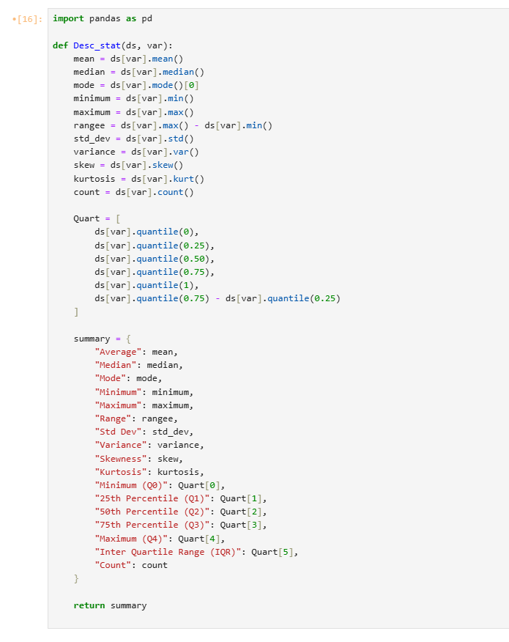

- Create a program to random sampling of size 150 and find the descriptive statistics for the dependent variable from the sample [Apply the descriptive function which you created].
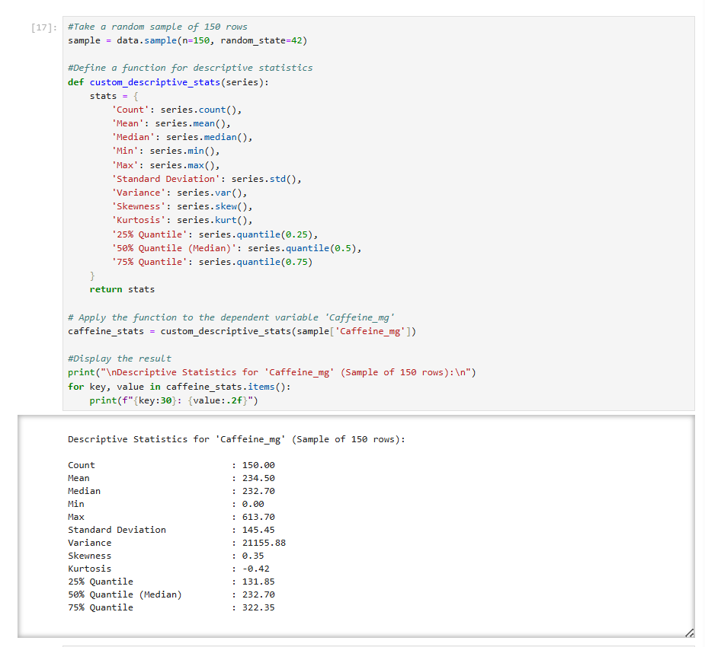

- Create a script for systematic sampling by giving certain conditions and finding the desc stat for the dependent variable from the sample [Apply the descriptive function which you created].
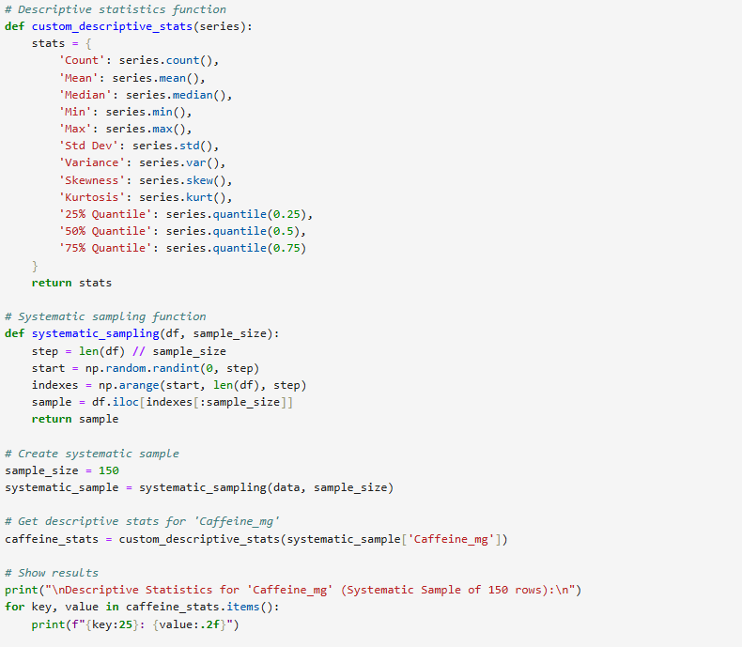
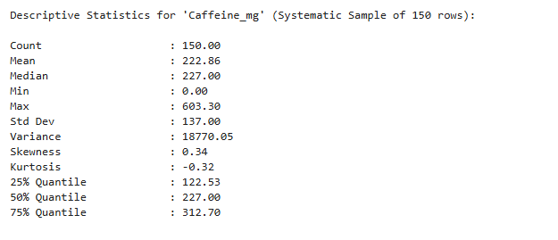

- Create a detailed descriptive statistics report about the dependent variable of the chosen dataset.
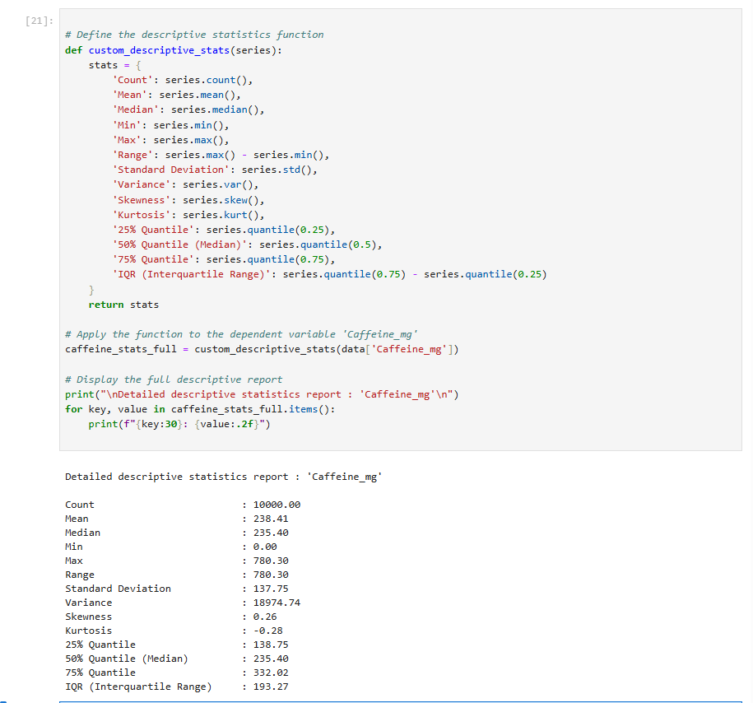

- Visualize the dependent variable by the Graph/Chart of the following using Python Program:

Scatter plot
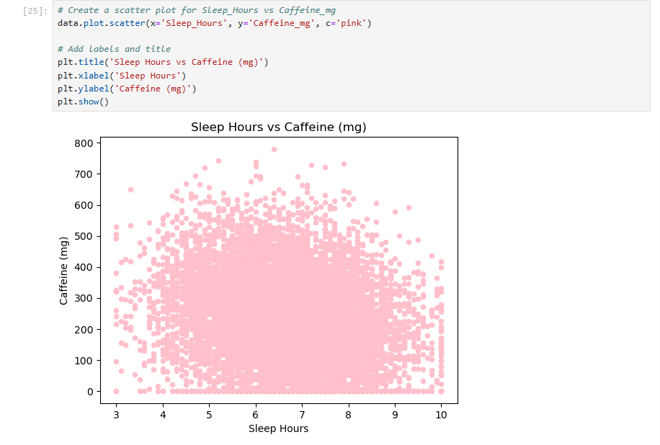
The scatter plot shows the relationship between Sleep Hours and Caffeine (mg).
As sleep hours increase, caffeine intake tends to decrease slightly students who sleep less appear to consume more caffeine. However, the data points are spread widely, suggesting that the relationship is weak or not strongly correlated.

Box Plot

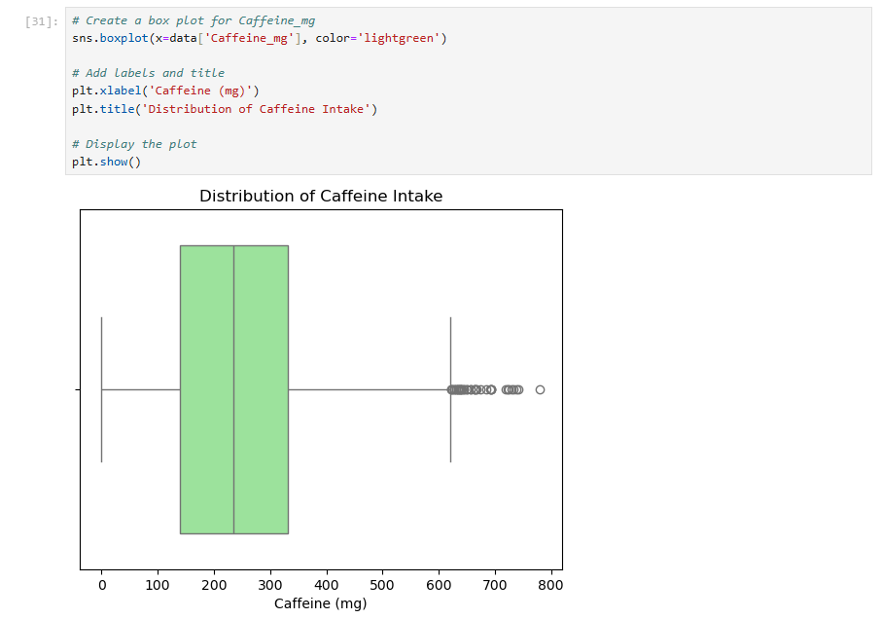
- Q1 (25%) ≈ 150 mg – one-quarter of people consume less than this.
- Q2 (50%, Median) ≈ 250 mg – half consume below this amount.
- Q3 (75%) ≈ 330 mg – three-quarters consume less than this.
There are also outliers above 600 mg, meaning a few people have much higher caffeine intake.

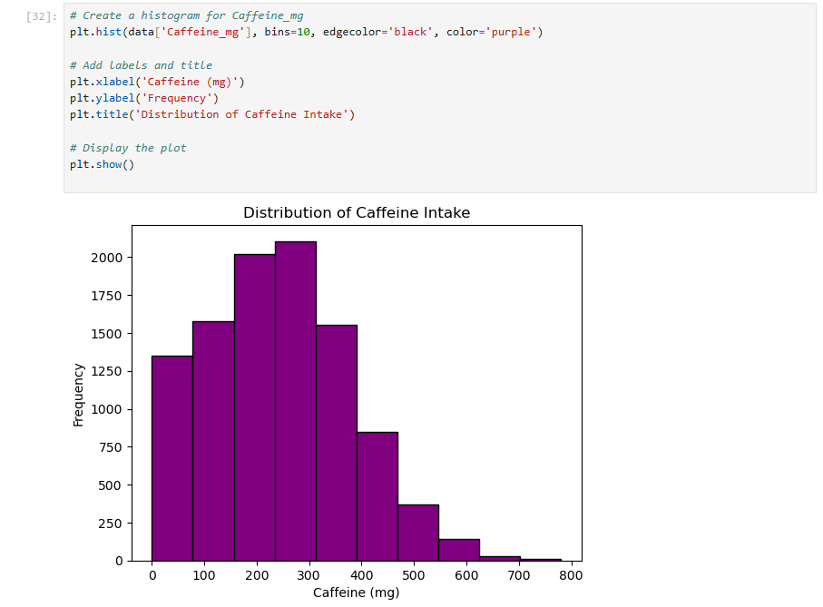
Histogram
The histogram shows that most people take between 100 mg and 300 mg of caffeine. Fewer people drink more than 400 mg, and only a few go above 600 mg. The right-skewed shape means most people consume small to medium amounts, while only a few consume very high amounts.

Heat Map
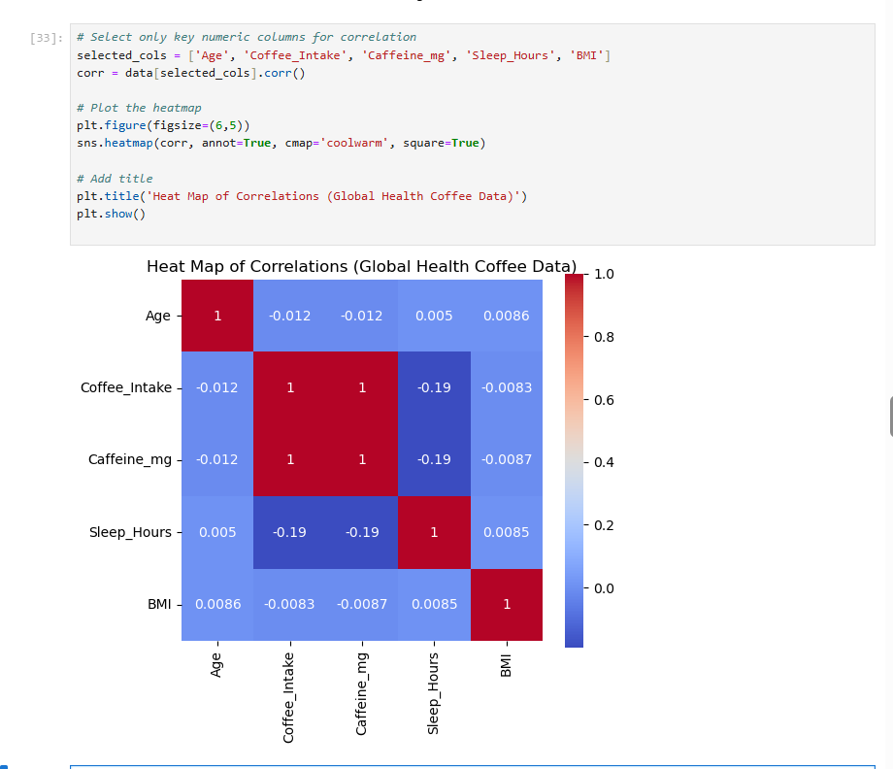
Hint: Use Matplot or Ski-learn library

- Perform the hypothesis test to find the correlation (Pearson and Spearman for numerical variable and chi-square test for categorical variable) between the independent variable and the dependent variable.
Note: If you have more than one independent variable, then choose any one of the independent variables.

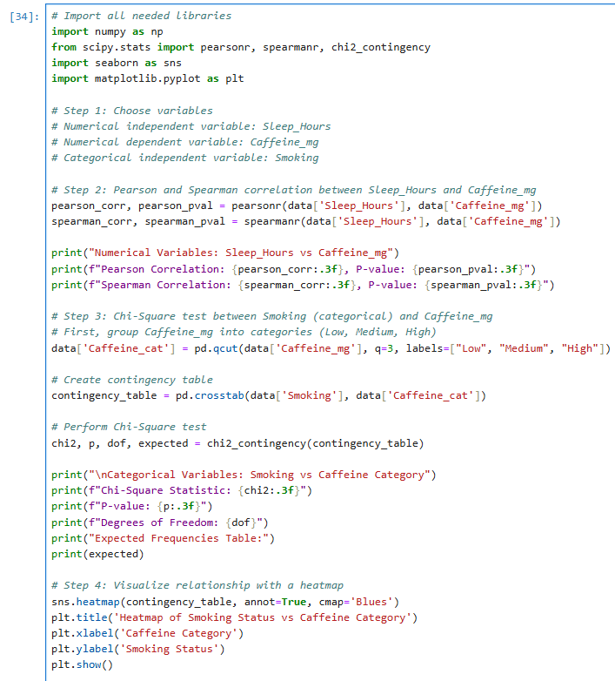

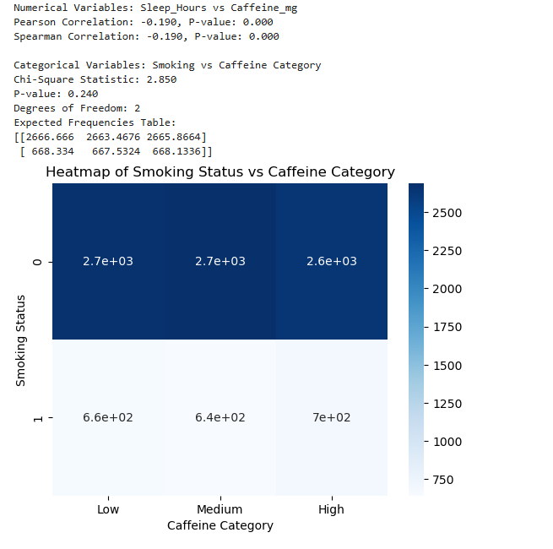

- Assess the performance of the dependent variable to know whether the sample is representative of the normal population by a one-sample t-test.

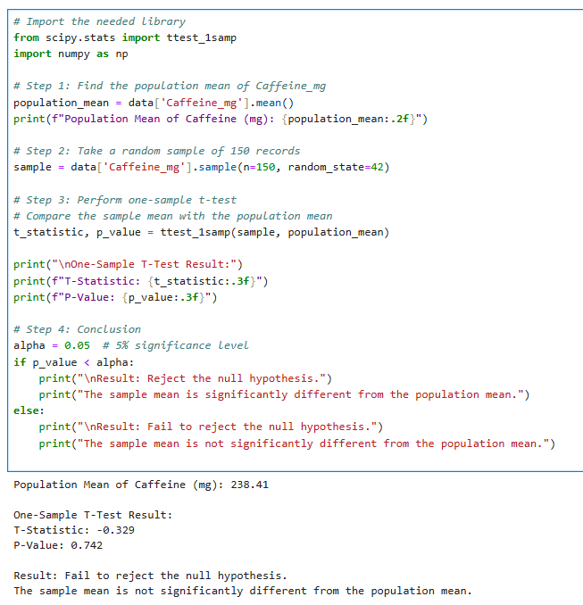
The average caffeine in the sample is almost the same as the population mean (238.41 mg).
Since the p-value (0.742) is greater than 0.05, we fail to reject the null hypothesis.
This means the sample is similar to the population and represents it well.

CLO3 42 marks

- Build, Train, Develop and Evaluate using Simple Regression for chosen dataset. 5 marks

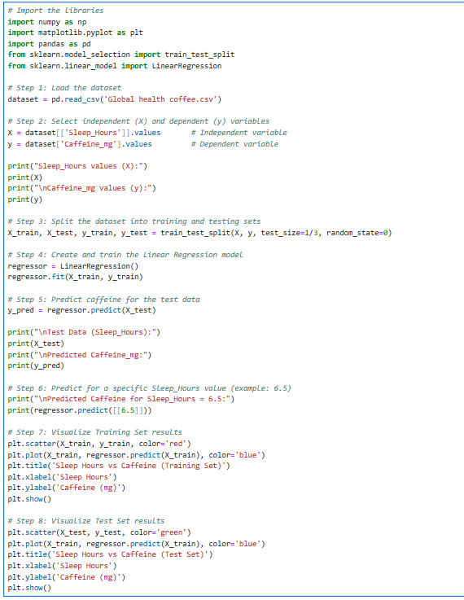

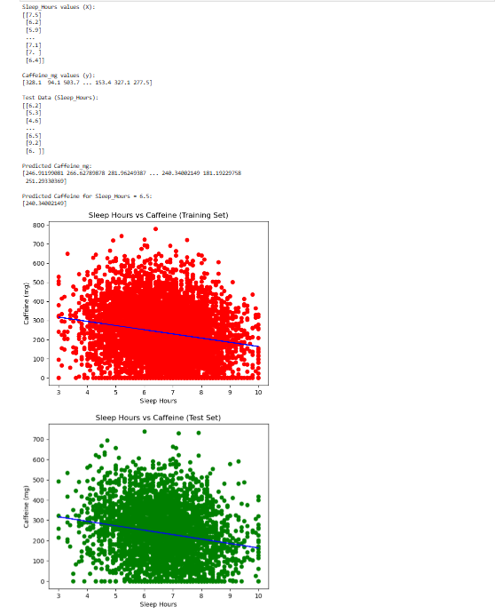

- Develop a script to forecast the value of the dependent variable from all the relevant independent variables using Multiple Linear Regression 5 marks

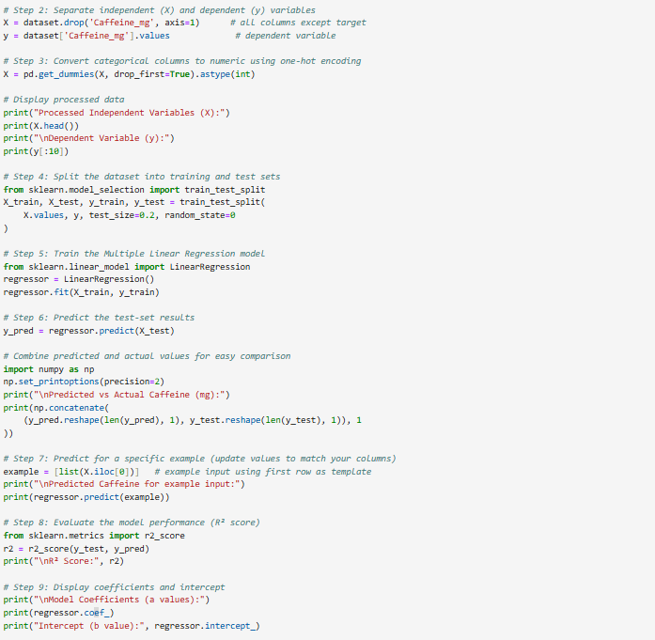
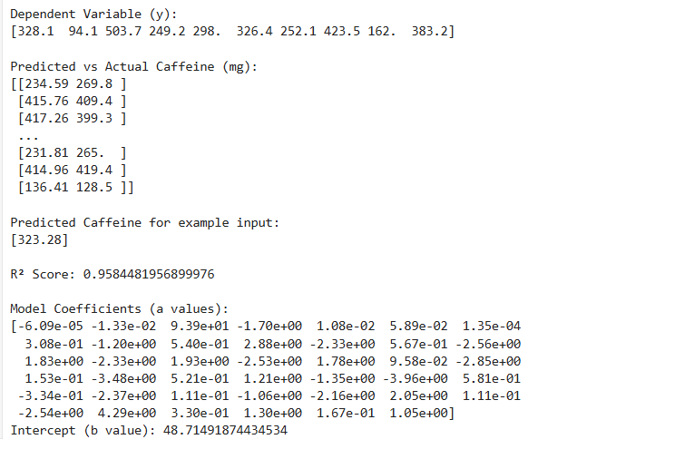

- Predict the value of the dependent variable from the different classifier such as Logistic Regression, KNN, Naïve-Bayes and Decision Tree. 17 marks

Logistic Regression

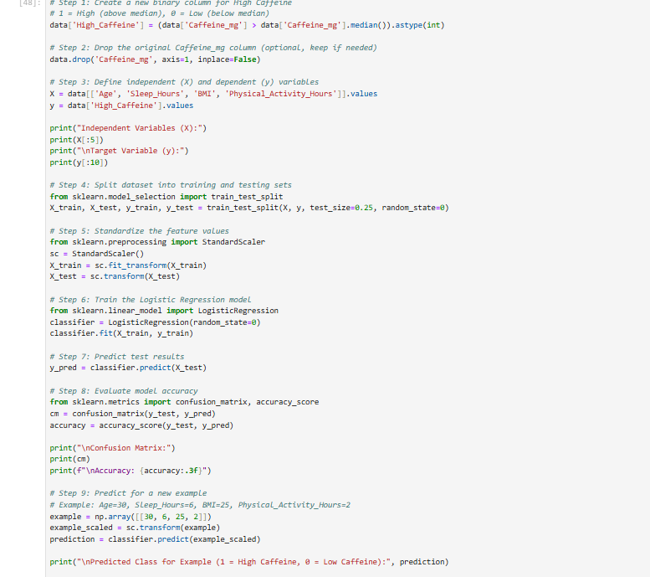
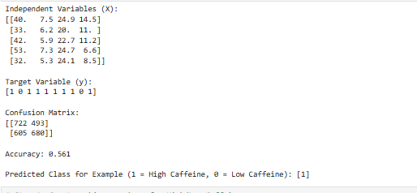

An accuracy of 56% is considered low, it means the model only predicts correctly a little more than half the time. It’s not very good.

KNN

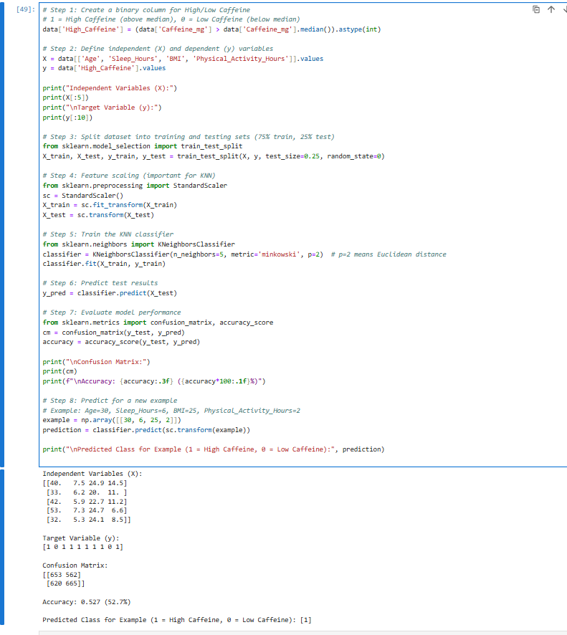

Naïve-Bayes

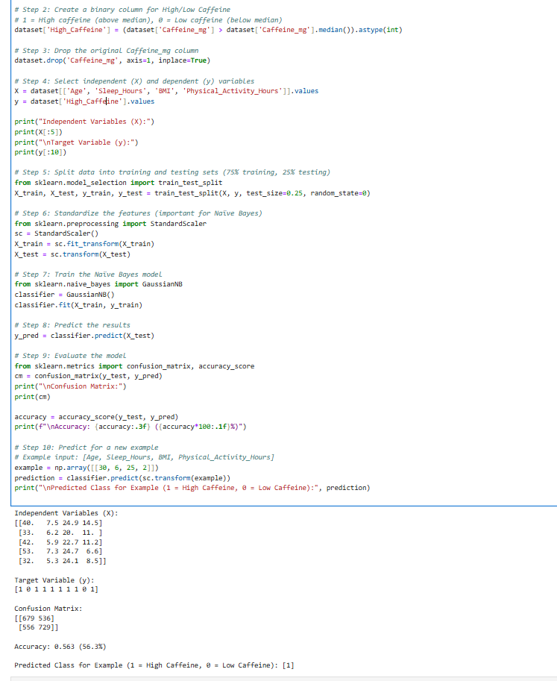

Decision Tree

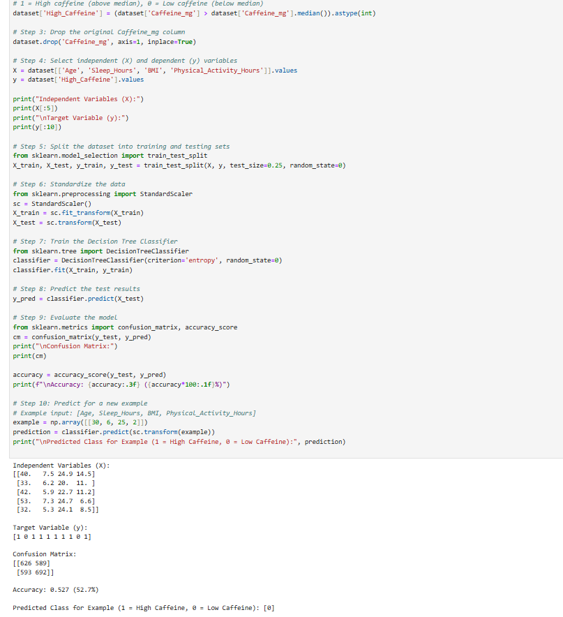

- Evaluate the performance of each model using confusion matrix and accuracy and identify the best fit classifier for the chosen dataset 9 marks
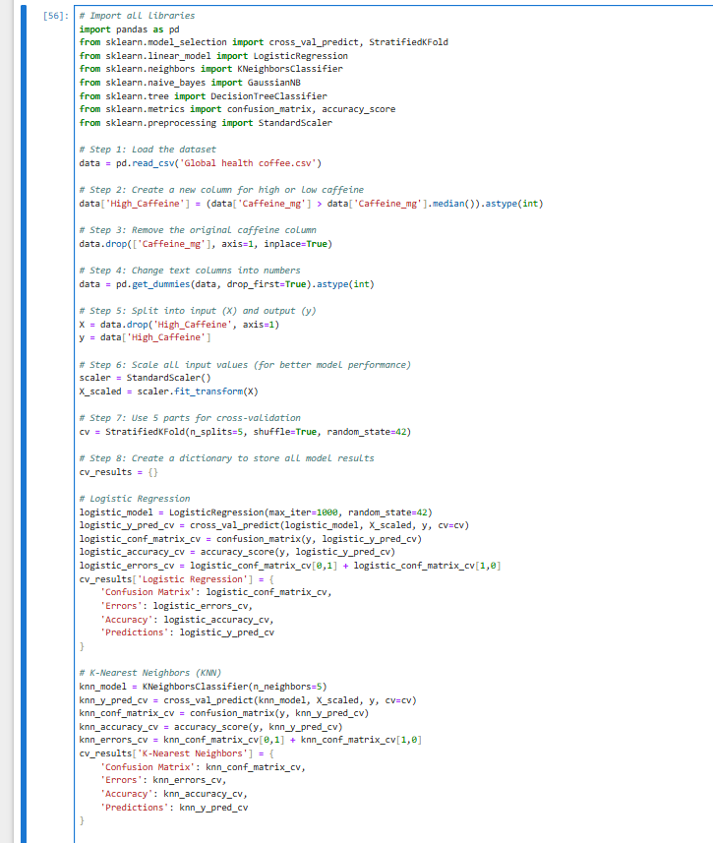
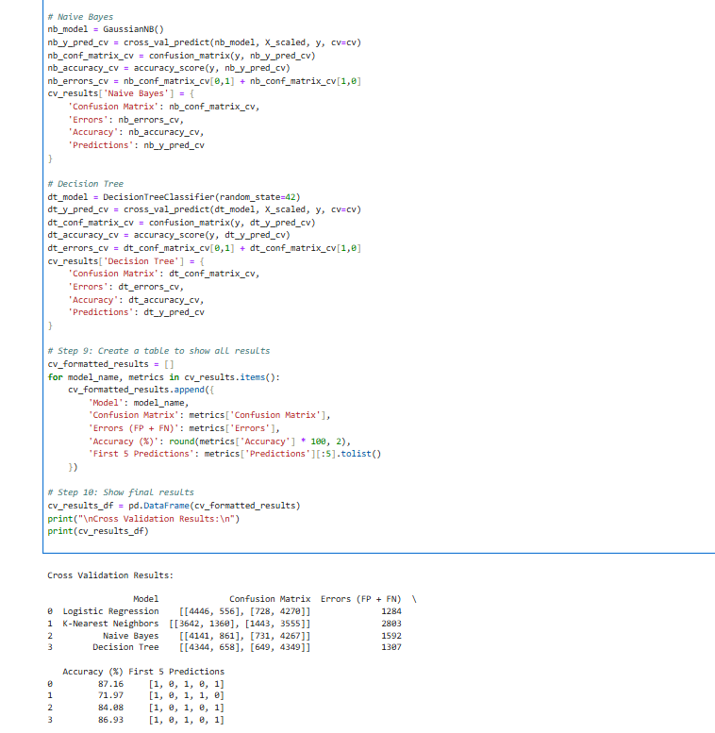

- Predict the dependent variable by using best-fit classifier. 1 mark

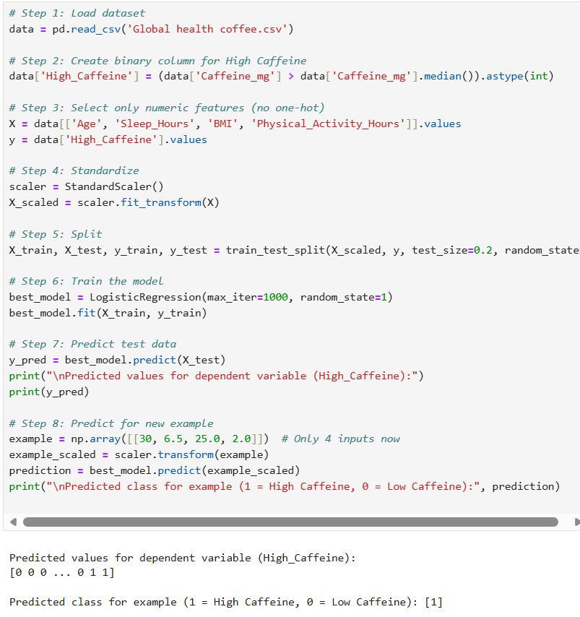

- Perform the cluster analysis such as K-means and Horizontal for any field from the chosen dataset 8 marks

K-Means Clustering

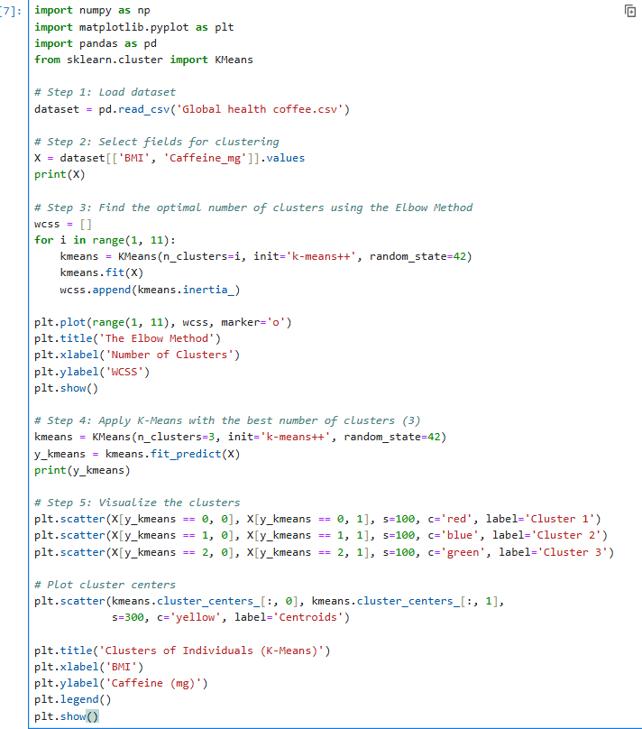

Output
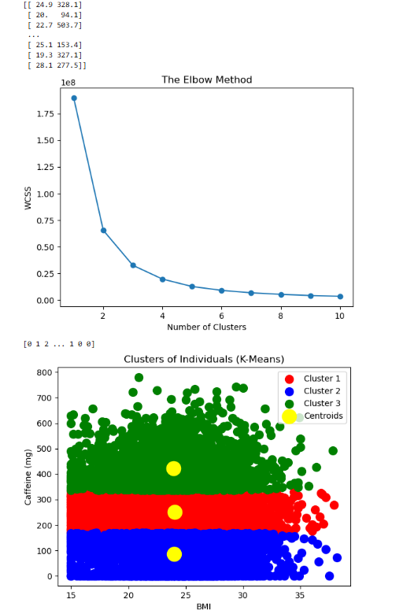
Horizontal Clustering

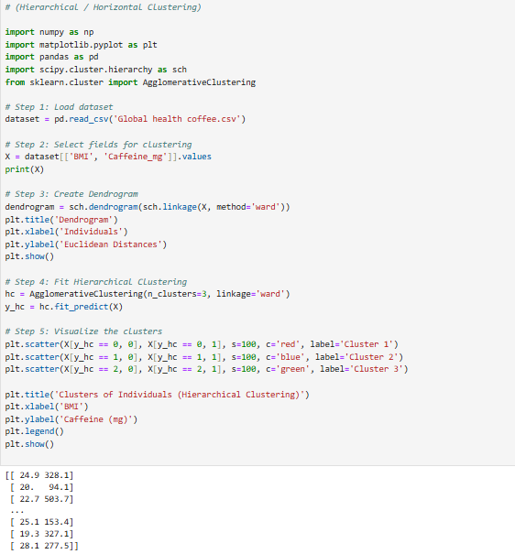
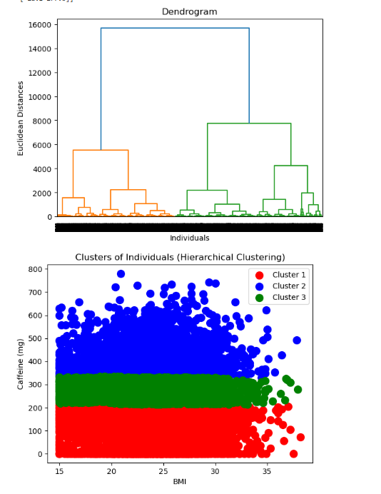

- Explain the strategy for improving the system after viewing the cluster diagram. 2 marks

After viewing the cluster diagrams, it is clear that individuals are grouped based on their BMI and caffeine intake. To improve the system, we can:
- Collect more balanced and detailed data to make the clusters more accurate.
- Apply data normalization to reduce overlap between groups.
- Use additional features (like age or activity level) for better separation between clusters.
This will make the model more reliable and improve prediction accuracy in future analysis.

CLO4 [

1. Create a new repo for project in Git Hub
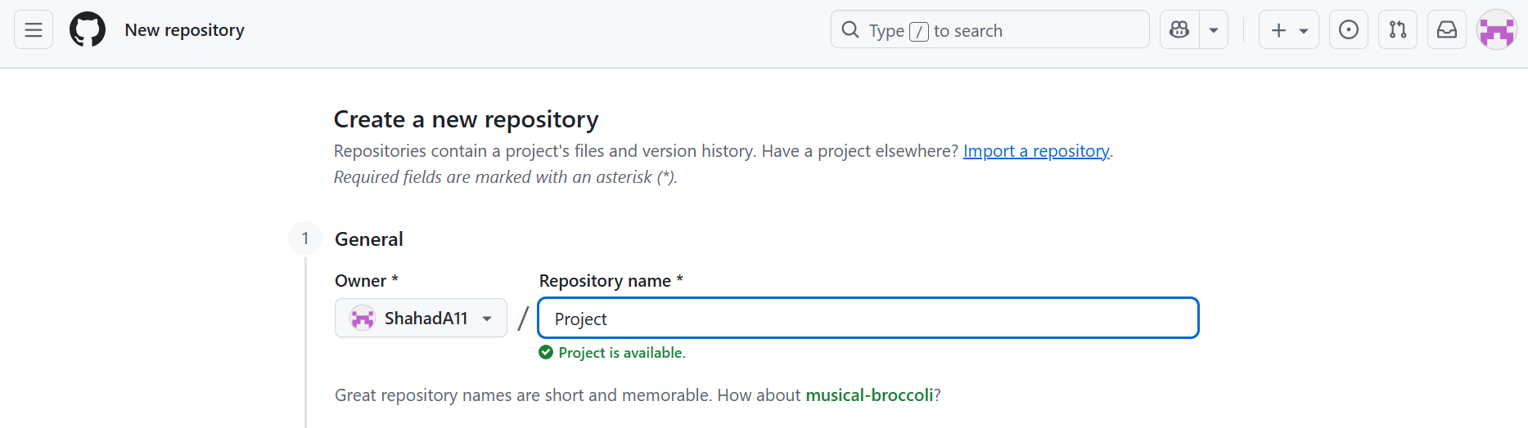
I went to www.github.com and signed up for a new account. After logging in, I clicked the “+” icon on the top-right and selected “New repository.” I named the repository Project, kept it Public, and didn’t add a README file. Then I clicked “Create repository,” and my new GitHub repository named Project was successfully created.
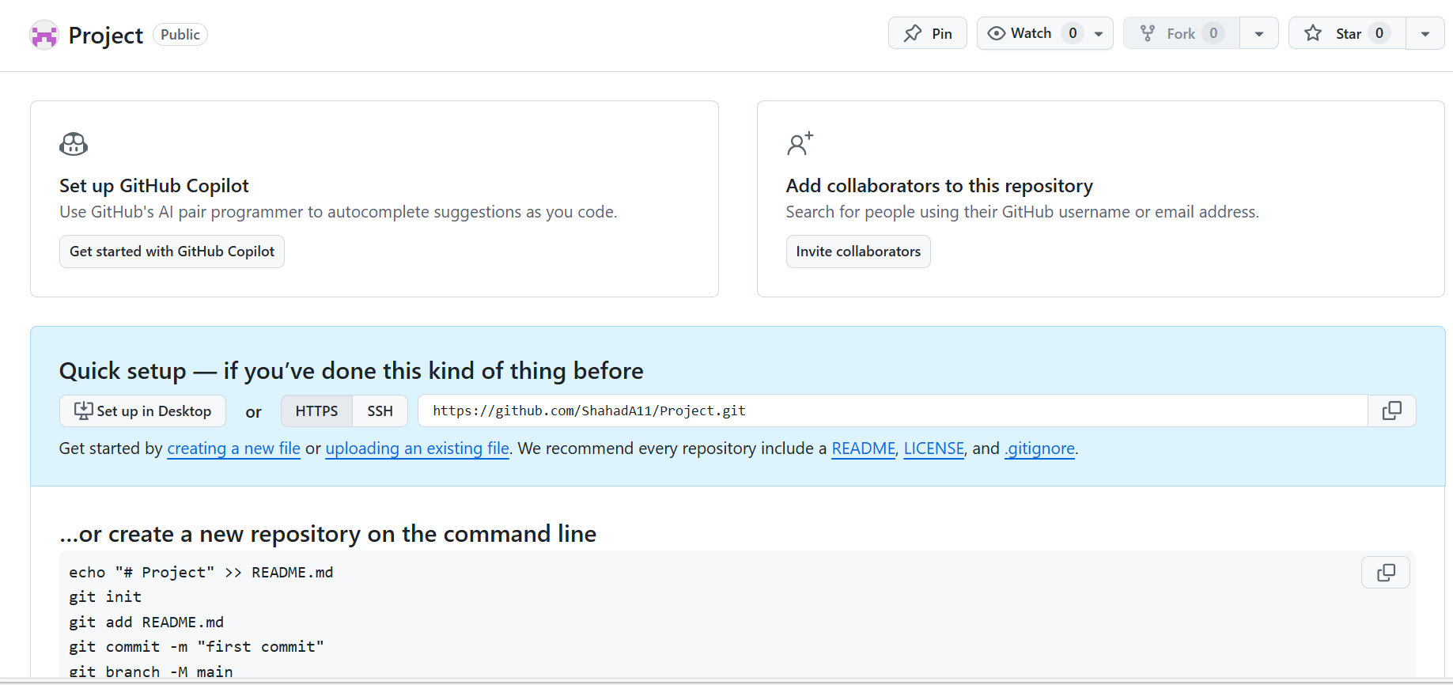

2. Upload all the project files created for CLO1,CLO2 and CLO3 to the Git Hub repo
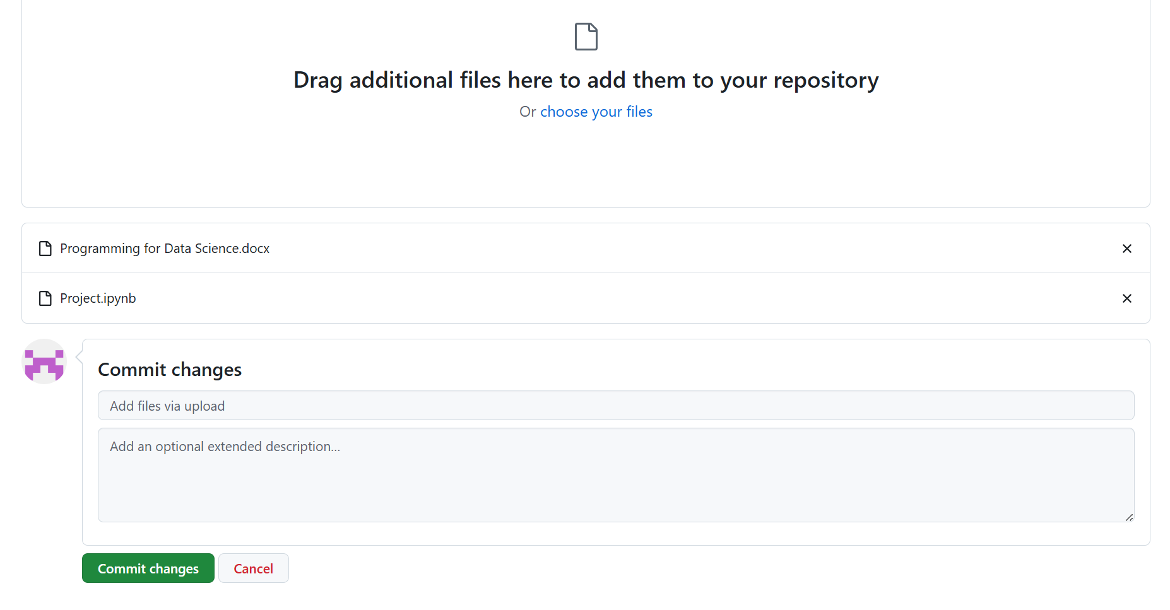
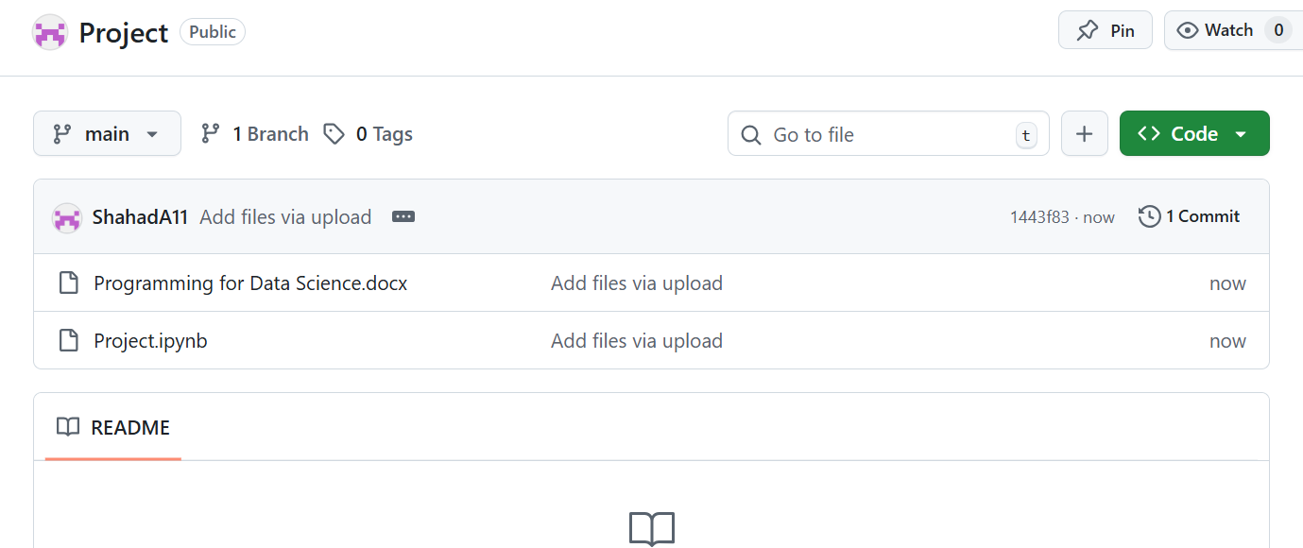
I opened my Project repository on GitHub and clicked on “uploading an existing file.” Then I selected all my CLO1, CLO2, and CLO3 project files from my computer and uploaded them. After that, I clicked “Commit changes,” and all my project files were successfully added to my GitHub repository.

3. Configure Git with GitHub

4. Clone Git hub repo to Git

5. Pull any file from Git Hub repo to Git

6. Modify the pulled file and push the modified file to Git Hub

